
Engage Women
Book Club
We will be reading from a list of women authored books from Persephone Books.
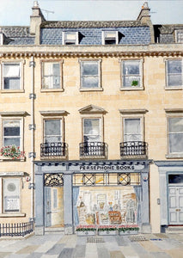

Persephone Books reprints neglected fiction and non-fiction, mostly by women writes and mostly dating from the mid-twentieth century. All 152 titles are intelligent, thought-provoking and beautifully written.
As well as novels we publish short stories, diaries, memoirs, poetry. Gardening books and cookery books; each title has an elegant grey jacket and patterned endpaper, along with a matching bookmark.
Our first book is Crooked Cross by Sally Carson
The heroine of the novel, Lexa, watches her brothers being seduced by National Socialism, as she observes her Catholic fiancé losing his job because he has a Jewish name and, by the summer of ’33, is deprived of basic human rights like sitting on a park bench. But despite the grimness of all this, the novel remains intensely readable as it implicitly asks the question: how could the country of Beethoven and Goethe, Freud and the Bauhaus, be descending into barbarism? Why would the rest of the world not intervene before it was too late?

